Simulation waveform:

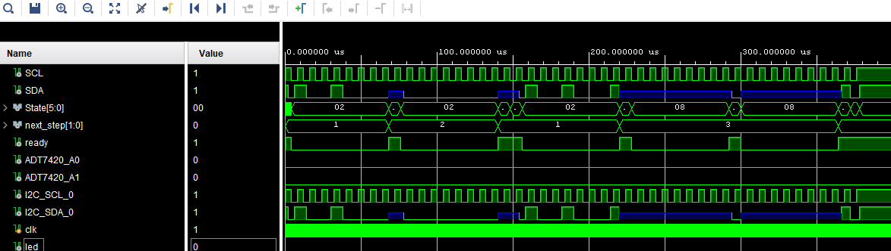

ILA waveform:

